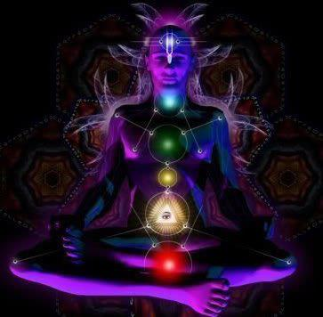

www.discoveringyou.co.uk

Friends of DiscoveringYou

Presents

An Afternoon of

Holistic Healing

Saturday, 23rd February, 2 till 5pm

The Quaker Hall, 18 Dundonald Drive, Leigh-on-sea, SS9

Admission £1 per Adult

DiscoveringYou wants to help you go within to find your inner self, so come along to this wonderful afternoon of Holistic Healing. You will be able to find out some great information on healing techniques, try a free meditation, Yoga demonstrations and meet some really great people! We will also have some lovely pampering for you and yummy cakes!

Soul Signs with Dee-anne
Robert Fairhead presents Hypnosis/Psychotherapy
Holistic Healing and Pampering with Angela at Pure Indulgence
Yoga Demonstration with Roger at Yoga-on-sea plus
Free half hour of Therapeutic Yoga
Indian Head massage with Deborah
Gel Nails and Pampering with Karen’s Beauty Retreat.
Free Meditation at 3pm Yvette at DiscoveringYou
Reflexology with Lee
Arts & Crafts
Cakes by Laura
Crystal Healing With Matt Keane
Self Help Books and Angel Card Readings
Tarot Cards with Jo Tiller

Tea & Coffee

